GRAPH

October 26-29, 2008
McCormick Place South • Chicago, Il
Session # 69
Branding Strategies: 9
Do's and 1 Don't for
the Digital Age
Featured Speaker:
Rhona Bronson

NAPL
Excellence
in Business
Management

Branding Strategies

,\'1

Initiation of Voluntary
r-1ovement /1tluitlt11X:lO!tU Cutlet

Marketing Mindset
9 Do's and 1 Don't
for Marketing
in the Digital Age

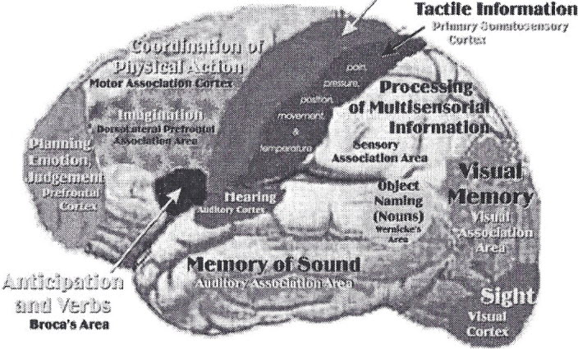

C()l)::~tl'f,Sf.b;~~?r£l
C~IQ~-l'l!~, ~~(dCQrlt'iin(a.6w {;miH ~hrR""i.e .•• -Wi:.t.;ttJtl/\l .• A~~k~

©NAPL

Excellence
in Business
Management

What's right for you?
Depends on:
- Your comfort level with new
technology
- What you have to say
- Your brand
- Consistency with your brand
- Your ability to master frequency

©NAPL

NAPL

What are you waiting for?

"

Excellence
in Business
Management

I'
•

September 27, 2008: Google
Search is 1 0 years old.

II . . .
I' :::i; '.. . ........• '.' ....
, .. ":;.,.,.". ..... 1 .. A"'n,a.,,'ly ... t'IC.'S'
:.: .. "',!:- ..•. : . .;" : .. , . ·if ..

G
·
-~

·'1:···'·'···.
...
···C···:········.
," -.
'"v,_, ",. ,_.,

Have you Google'd yourself?

©NAPL

~.®
~
NAPL How to be searched or found
Excellence • •
in Business • Changing Web Site
Management
- Directories
- Key Words (Tags) on Web Pages
- Blogs (Tagged)
- Industry Affiliations (Board)
- Speeches (Rosters Posted)
- Press Releases through e-wires
- Press Releases posted on .com
News and Publication Sites
- Activity of All Sorts

"
©NAPL

NAPL
Excellence
in Business
Management

The Take Away
"Brush up your online image and keep it
polished. "
"The old business adage that it's not what
you know but who you know takes a twist
in the Internet era: it's what you know
about social-networking sites that can get
you ahead."
Sarah Jane Tribble, "The Social Network as a Career Safety Net,
nytimes.com, Aug. 14, 2008

©NAPL

NAPL
Excellence
in Business
Management

The New Web
'We6::::1.0 ; Web"2. 0
Static Live

Publish | Interact
Inform | Engage
Link | Tag
Sell | Socialize
Control | Collaborate

The Age of Engage, Denise Schiffman

©NAPL

NAPL

Excellence
in Business
Management

Web Positioning

What's the most compelling reason for a
customer to do business with you?

Is it quickly apparent on your web site?

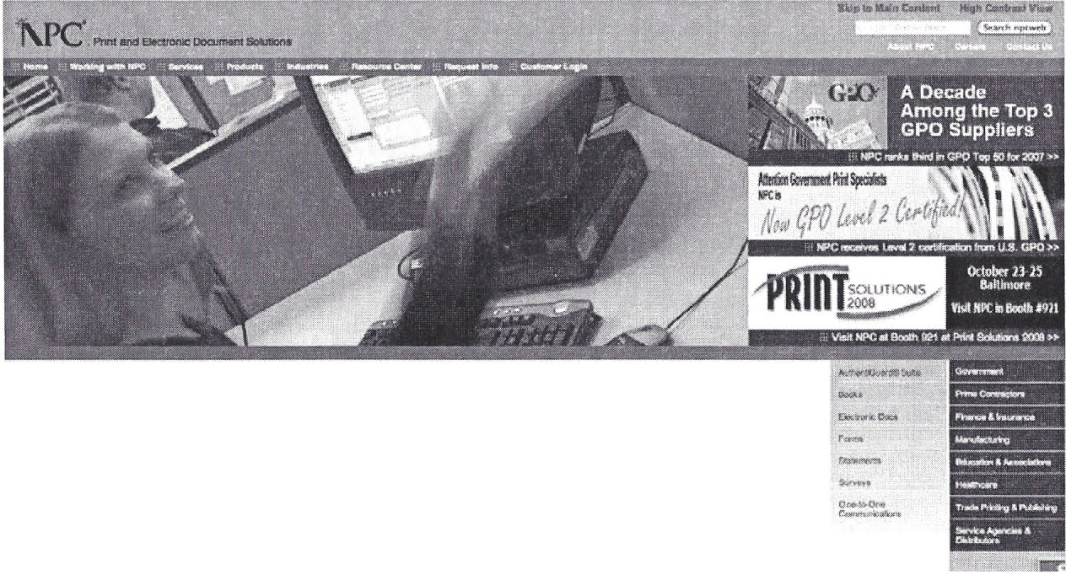

Delivering peace of mind, pt,,:. ct~~, 1'nIm:!Nf tMt.':Il.nti-\)i;/tfl ~,m:w~fli~nWda~1li.~;~l" U:~Wf~W y«,; i.la~!jltt"l;lftf;ra.."l:I:t'~}~n:lill'!",.!l
~,PJ!'!y1!l.a:~(t.~),.Il»!;;i)rt~.1.1$ll)ni~O·tJMmt:al'>'~i.ll9. D~~_~~.· ~.~~ $.11"" J:1r'~~ t)~t~-n~1"I1~~'jIjV

Nf'C~f"iO?~ j!l.>'I'mhhiy~-l!;:;1l!{'~f,fwv~ ~ J"Ji~ wli h,,,,,~::;t~q;.ii, •.• ~~ '!'>'ill. ~1!~Mr#ll:$hqnCZ!y, VJ:, ~I~~! ~ t;.r~liIT'~~I!i'::j:;;r~~I1I~J~!x! ~
r"RcP"NV.Uill{ "' ..• Pk\:x}lJclw~'" ~t~iJrJCf~,witj~ '.if~H1'l:9~l\ ref ~~~ INlt"nifl ~~'Ut~~. Qi'~ftl#'Vit41i~

ew-~\':1liQ') & "t'P"\1«*~ \''''~Nm~ oS 1$~1Wt1$"m~km r,."lt:h~>tl~ tlIS~t;,.:.ti>;'"(\ Wjl~i~,<~~ ~ l"\~wr M~~
ftruf~&~m ~.allmlY~:Iil.,~~ ~;~reM4"'$~l ;::~AO'it''''oi¥I~~ii
a!M~ MJi&!4 ~,;!!t¢

BEST PLACES
to work in

©NAPL

NAPL Competition Responding
Excellence
~a~~~~~~Snt Marketing Sherpa Study found:
- 38 of companies are increasing
their online investment
- 53 of respondents are investing
more in e-mail marketing to house
lists
• 47 are increasing spending on
Web 2.0 strategies.
Takeaway: Even with a recession, you
can't afford to wait.

©NAPL

NAPL
Excellence
In Business
Management

Marketing is a Must
" Now, companies are required to have
a core competency in marketing just to
participate in the marketplace."
The Age of Engage, Denise Schiffman
Conto.ct Center

<; s. /"< j~ C 11

HOME C,;"PABIUTI£S BRitt>: &- MORiAH KND'NtEDCE CENTER S£R\f\CE CE!'iT(R £V£NTS MY SF'! D.';SH80ARO

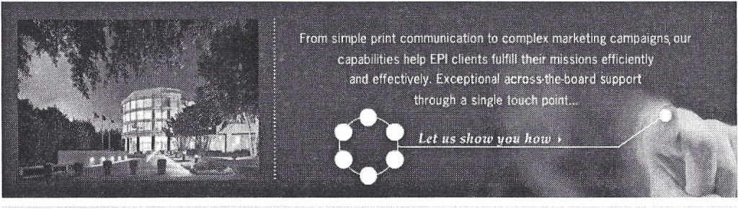
My EPI Dashboard Service Center Knowledge Center
Our powerfut web-based portalgwes your Makir.g your life easier is our job. Here T~<8 more you: kr.'C'w, ttJ,e gre-ater too
intemaland. c.xtomal clients one-tcuch you'D ur.:d Quick access to our FTP:siteto possemes. We're happy to share ICtarning
access to your suae of communic,ations lIpload your fiies, as well as several forms cpporturetes with you as ttH!}' arise. Check
and our suite of setvjces. Convenient, you may require while :doing: buseeee with here etten fer more insightful resources.
seamless com\ectkm at the :click of a us. Q.Q ~
moIjS~, @Q~
fup

©NAPL

NAPL
Excellence
in Business
Management

Social Media Revolution
The ultimate party scene.

Multi-conversational
~ ~
Message -+ +- messages
~ ~

Make sure to Mingle!
©NAPL

Excellence
in Business •
Management
NAPL

General Research shows:
60 of Americans interface with companies on a
social med ia site ¹
- 85 believe a co. should interact with consumers
via social media'
- 68 of American adults visit online blo.Qs,
corum~nities or social networks vs. 42°10 six months
earlier
- 33 say they visit sites to read up on
product reviews²
- Today, on a daily)basis, 11n 5 adults (~ith more
women than men are surfing the web

12008 Cone Business Social Media Study
2 2008 Insight Report from MarketTools

©NAPL

Excellence
in Business
Management

Social Media
Real Definition: Internet-based
tools for sharing and discussing
information.
Loose definition: Anything a
consumer gets electronically --
including e-mail.

©NAPL

NAPL
®
Linked In

Excellence
in Business
Management
Linkedtl·
P~... -Job$. ~ At'.w~.'" Co~~~ •.
~li~~
~<i!'{U>.l~'
'tM ..••••. j\-;~
~h . ..,l-
!i~P'
NII'4I''''~
~l't;<='ff
J1~~
'~Clli'~
~t."\OQ!..~{9~

~;~"'~< ~¢n*,
lJ ••• *;~P)
Q-~~.ri:

~~~~"
~~f.4J¥$*\~)
W"'"'
(l,v.;f:'i

J""
~";~'01<
pJ~

. ,,"-
Sirootio(!·
M:~!IE,~t;::<~ ..•
~~~l~~
~.'''y¢q~II'9$.~
_ •• iT@ •••l
}-r:u~'1¢.N~~
~-!Y.l~kl~l
~ "'!f ;,:;~~~ f.:a"".".~ ll"" 1'I"cHt·
Rhona Bronson r&)

fI~@tjrQ E)tfK1.it~1t Fl'rlrit!fl9aOO: ~hN!li
Cffla.~~ N;fI\jy y~ Of, Mil
r'torii'o
Cij)"t:,l" II Stln!« vr M MU'k#(fttlf a! NAPL ,...tlfIn.~
At~.bOfl of Prh~br;g low •••
p,st ~ Man;Mm~'~~'OO:fM~n.l~I$fh"MnQ~GroiIo
- e<~tJ¥.l«l',~~ #t N!t'NJ~!W'f t\'d'~
- Man.et:irq Ok~or ~ NAPl
EGue&tjGM • SymCfJ!lf!! \IN;IEt11Y • MaxwtU .S(;~.« Otit~$~ec
and :PutJ\G At'!{lta
- S)'llttt.nlo. ~i.JorM'Y
C~m"~-U~~ (;@ 32~~'1jQ(1;i

I""<h:,t~by Mdolil_~l ~M"~it~l
~ItH .My'i=I~
- MtVt~t!\""
- My C<.Iripaty
Pt,!l)U"P!'ofi14 hu4t:Jf~.lirj;edn,"~~4i'~
summary
Ii, MH!i(y ~:t:i1~ 1P:~i(a(iy~ ~l<)i.titf!i in VlQ prlntiniJ:{In(1'sJ!#ltlhil'l9
~im9..~tEdto~ilgoNf!'W:~ W:()tl,l~ Ir.!M:!Il:evalue dprint
~1)1r~~~ln;1;n,~~'~~'\O\~J:"ClI':;i~-.W~g~trit
~r'S Otl~t "t~ vib!1m! I» -# ~,~mW*!jti!;'r!~ "¥#N$# M ~~ i$~~(,lV~~
~analt:"!e.> ~f9r.ieWwOOi.l~mat"\)'~, tht.mOlt~malie
~ •••• ~h~WI.~~it
Profile Page
I$<¥":~ ~ S~h~.
<;,; 1.;-:".' ""~;;~""': ~':.,,?,,
:e, Stn6Icl.-!~i

~ G'miM~94til!\.~i,'I.~~'(":ti.,~
~l\ifdm-~l.Q~-ll«'MXk.
,~p.
RMt~R«~m.~
P'-~1~1
J'«Iiu.u·~no
P>l"':;¥;;hm-~:, 0:; i t~·hU. t~~"It.t ,ffl~¥ ~1,*~,:1l
Qi~l:l
:..'if) JW1"';;U trlfl: M!It¥ll1 :l¢tif rI':'ftlt'l:itffl-6'L,
Linked 1m 0
"-'" J_

P: ~!.>;;~'"
.Wt~;jH
!..:.1.j..'t~¥¥.i"l1
f;'4~.
~f.:t~'
!~b<#,«JK~
;-"';Y'l:-U¢'!"~
~f'::£'f:m
!J.t;(;6r.~a
~~:b<l- .• (t:J
(.~<":"'.y~,¢ M"'~'~'l~.jjl
!.·-#io"":l<'~~
'rUN
"1r:o~~",·~:1~:"';<!
:»~~~~~
~~
U-AAj:!l)
~-;.t't
1f;''''-::M1I'>'e<'';:«'<:><:'-''
tt(0!j~~~

••• Rh~na
!!JA e~¢I"!
\~~~:!it~,.')"." 'W'-;:(~f'-.)(ff'~
At"~~~~'" C9m.,p.itn~ ~
N.'t.'2-.<--;.~ ,§:
NAPL Printing Business Executives
At}qn.»I# S~,,«.h p~
{l>.""lI"lii!::,,, O!WJ$~it)n-$ l)p!'$o,'1hn.. ~flmb-I'!n S~ti,"* M>:lI'lljgr~
Members (82)
J."f/ Pink"; \,.",

V:"v ~l:WUl:"1 a~t><.· •. ~a'lV C--t>f1~'!j'J"~'"'t->::""l.C~.j"J~
CfC>1;~~4'!:'>w <fen.. G,t¥ A't-u
M'file!l) o::'~~~~ : r>$r.~ ~n~.,~
Oanio K.il8r,:{~
Ctm-,1!t IH T:)~ N~!'lg.{;t»r-r..;t$_ h~t (.~N1P
e~I!,~""FOf'< Wo<".n fo.'M
W .•. ,ko-!.::::s~~! :S~"ft"'.8.t~
Ii
Brent Wrn. Bauer .i';;:;
l>:.otl-;l'l~1;!'S~ P~;">::{~'t t-1:;:WJjt"¢! ~:"; "'l't<;;¢'t<~""t
C<S:i''':~>.;'\k;'<l'.!:$·:):,b!1
O",!lr--:1"'.~Ma;';'.t$
tn:.'<':t I:'; ee~f\f->.'"'i -' f~M t"l~n!l~
m
Miko John¥ton y;;::;."
. .t;,.,l,;,.",_lJ"''''St.·soiN: .•• ,_J_,;t!.w;J;t",,_ .. _· _
Group Listing
l:itl--':;lt:~-M¥'>J
1;
®;
~;
Q)
©NAPL
.

Which is right 4 U?

Excellence
In Business
Management
Recruit New Talent ...
Get a Job ...
Find Experience ...
Network ...
Ask a Question ...
Advertise ...

Linked

©NAPL

NAPL Simple Marketing
Excellence
in Business
Management
Jack Trout:
A Genie's Wisdom
" Marketing is simply figuring
out what you have to do to
sell your product or service
for a profit."

©NAPL

NAPL Reading between the lines
Excellence
in Business
Management
A series of techniques for translating
your mission externally and internally
(to the market, public, customers,
employees)
and inspiring audiences to align with you
over others (the competition)
for the achievement of your vision
(business success).

©NAPL

Marketing Old vs. New

Goal: Sales Promotion. Find
clients for products/services.
Purpose: Make a sale.
Products/Services: Print
Channels: Direct mail,
Capabilities brochure, Cold
calls, Sales visits, Calendars
Responsibility: Sales and/or
Customer Service
Excellence
In Business
Management

arketina:

New Marketing:
Goal: Niche Awareness, Identify
services for specific clients.
Purpose: Create market
space and sustained business.
Products/Services: Solutions. Print
plus media planning, fulfillment,
distribution, etc.
Channels: Internet, e-mail, e-
newsletters, personal selling,
speeches, specialized pieces, 1:1
approaches.
Responsibility: CEO, Marketing,
entire organization

©NAPL

NAPL

Excellence
in Business
Management

Key Take Away:
Be Consistent

Break Through the Clutter

Consistently do everythinq in
your power to keep aiming
and firing -- aka market
yourself effectively.

Military analogy: "Continuous
Aim
Firing"

Average message takes 8 times
to be heard.

©NAPL

NAPL

Excellence
in Business
Management

Mama said:

You only have one reputation.

Marketing is:

making your business more public and
putting your reputation on the line.

©NAPL

9 Fundamentals (Do's):
Steps to Success

Excellence
in Business
Management

- Define Yourself
- Be Credible - Show Expertise
- Go Digital
- Communicate
- Target
- Extend Reach
- Benchmark - Market Research
- Learn from Leaders
- Have a Marketing Plan
©NAPL

Sample Tactics
- Positioning Statement
- Tag Line
- Public Relations
- Story assistants (sitepal.com)
NAPL
Excellence
in Business
Management

Differentiation Tactics
Anything that tells people
quickly who you are or
demonstrates what makes you
special.

©NAPL

Excellence
in Business
Management

Printing Brands
Who in this industry
has a brand?

al1phOgraph^{i}iG8@
O£5!GiK •• COPY IJ!fiHN t .'" tOMI\WNI.tAtE

What it is?
What did they do to
get it?

Qyad

dnvmg

©NAPL

NAPL
Excellence
in Business
Management

4. Communicate
Market Speak: Create Frequency
Frequently communicate
Consistently differentiate
Don't use templated anything
Commit to multiple hits per target

Sample Tactics
- Create an e-mail newsletter.
- Use Plaxo cards.
- Design campaigns not tactics

©NAPL

NAPL 6. Extend Reach
Excellence
~a~~~~~~Snt Market Speak: Advertise & Promote
Don't preach to the choir. Outreach to prospects
Use multiple message channels
Stay on message
Use material that serves double duty [Rockaway
Commercial Printing]
Promote out of the box
Don't just do it yourself. Use creative experts.
Sample Tactics
- Billboards.
- Direct Mail PURLs.
- Monthly e-newsletter
- CEO annual checkup call
- Radio/Cable TV

©NAPL

8. Learn from Leaders

Excellence
~a~~~~~~Snt Market Speak: Dashboards and KPls (Key
Performance Indicators)
Identify Leaders
Determine Leadership Positions
Leadership Characteristics

Sample Tactics
Performance Indicators
State of the Industry
Top Management Conference
Peer Groups
Courtesy Calls

©NAPL

L

Excellence
in Business
Management

10. Don't

BLOG.

Why?
- Capability. Most printers aren't writers.

- Time. Most can't do newsletters much
less blogs consistently
- Mission. Needs to fit with plan

- Voice. Need for authentic "voice,"
POV, or position. PR agency can't
write it for you.

- Priorities. Other things to do first,
ie.FAQs, dynamic web site

©NAPL

®
NAPL
NAPL Resources
Excellence
in Business
Management
"""'1oJrIo\.~III,_:-·_;«:II:
M:M'*ffinf)~.""'''' ~
~~~~~-~ --..
~""-"---.,,,,,- •• ~- ~II("'"
~_ •. ~ i;W,_ ~
~"""'''''''-''*'~'-''''''''-'-''
- ..... -'<-~- .... -~:~ -~""'~
--""""",~ . .., .. "",-~ •....• ~
_==-==z;~~.::!.":7~--=:::'
::E.:=::a~-~--~
~,*IkII~
~#_--,,-,*
l:l1!l4l;:;\,lO)!:;~~~_..".
~ .... ~~-,..,.",
--"'''''"-....,.'''-
-""'_ ••....••..... -
"""":_'"#>t-"h_~fO:
~-"""-, ..•.
~~""""'~""""'I
~~"'_I'k
~"';#'''''''M#'''''''''''''~-~'
:::7=~~=
_ .• ,-.-"",-
::"~:.:t..:=::
::-:-::-,.:.:
~~~-,.,.~
.••. y_~ .• r:M
~-"'~¥I'\--- .••
~~~~
~'::::~ ...•..•.••. -
~~,~""-,,,,,-~:,,,,"-,,-,,,-,,",:,,,,,,~
- .. :~- .. -""._----
•...•. ,...A_.:~"'-- •.. _,.
_ ......••... ""' •.. '_ .........•........ "'.
::::~~=~:.~..,."::: ..
~7!E!~:;:~~ ...
s.a:=:~~
--,""""''''''-.,.
--- --~ .•.......•..... --..."
~::.~:..*==:..!'.:':,..,
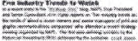
~:::!!!::!'..-..... .•..... --"
_____ .'"'.. -;"';_'!'~i>_M'i<'~
-<>
!+>""!4~
~--
-
.. -
r~t-"-.."'"
~ .. ., •..
-~
-.---
e::--
"'--~.~ ..
~~
........• -
-
=-~.
--
-
=~~~
~.::
Friday, Sept~rn!:ier 26, 200a
Where's the growthco'ming from?
I stumble into printers who are stili growing by double digits. You dont see them
as often as you used to but they are still out there. I also hear of the ones
whose business is down.by that much. Where are these guys getting the growth
from? The economists are telling us that markel growth has stalled so it's gona
come from somewhere ... hmm.
About Me
MIKE PHILIE
Mike is a vice president
and consultant in the
Print Consulting
Services Group of
NAPL, the not-for-profit
I'd bet that much of this growth is coming at the expense of the laggards. The
__ •.• __ .•.•••••••..•.. ~_ •••••.•••••.••..•..•. :_ •• ! •..• ~, It •.• _
NAPL
BUSINESS
RBYI[:W
1'1,;.\'t:{;: t- -~:-iF PH.! d;
#UUM..,.~ __ j.at;,~
I'~<~i!f'l<c-ilf':frn/tl.
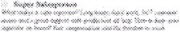
~
~.,~.Ift{
~";,--~.".><.-~
©NAPL

Social Media Speak
A Glossary of Terms

Excellence
in Business
Management
Avatars. Borrowed from the Hindu avatars of supreme beings who come to earth in
different form for specific purposes, on the web the term means characterizations of
people usually in animated form. Used mainly as online customer service reps.
BLOG: Short for Web-log. Started as a means to have an online journal. Has
blossomed to become a means for regular communication to small communities with
similar interests or concerns. Most popular in political circles, but used extensively in
business and on media sites similar to columnists in newspapers.
Blogger. Also known as blogspot, a free blogging tool used by individuals and people
just starting out who don't want to pay for blogging services such as Typepad and
Wordpress. Affiliated with Google. www.blogger.com
DIGG: A news aggregating web site or reader-inspired daily newspaper. Content is
submitted daily and voted on by readers with only the most dugg stories making it on the
front page. Voting stories up and down is the site's cornerstone function, respectively
called digging and burying. Digg's popularity has prompted the creation of other social
networking sites with a story submission and voting system. See also Reddit.
www.digg.com
Del.icio.us. A social bookmarking site that allows users to save their favorite websites
and share them with others. Can be a way to appear as a recommended vendor if your
website is bookmarked under printing or another business-related category.
Facebook. Calls itself a social utility for connecting people. Photos and videos can also
be uploaded. A preferred favorite site for young adults, college and younger students for
staying connected with friends and classmates. See myspace. www.facebook.com
Flickr: An online photo management and sharing application that creates photographic
groups or communities around shared interests. Basic service is free. Groups can either
be public, public (invite only), or completely private. Every group has a pool for sharing
photos and videos and a discussion board for talking. www.Flickr.com
Friendster. One of the original social networking sites that served as a model for My
Space and Facebook. Is popular in the Philipines.
Google Ad Words. Text ads using key words about your business placed on key search
pages. When people search on Google using one of your keywords, your ad may appear
next to the search results. Payment is by number of clicks.
NAPL. 75 W. Century Road, Suite 100. Paramus, NJ 07652-1408
Phone: 201-634-9600.800-642-6275. Fax: 201-986-2976. www.napl.org

activities through posts, e-mail, lists and instant messaging. The main types of social
networking services are those which contain directories of some categories (such as
former classmates), means to connect with friends (usually with self-description pages),
and recommender systems linked to trust.
Stumbleupon. A compilation site where you see sites and videos that others have
voted worth viewing, and where you can search by topic to see already filtered web sites
that match your criteria. www.stumbleupon.com
Twitter: A personal hyper-connected service of bite-sized updates on what people are
doing in less than 140 characters, i.e. "Rhona is at a concert and now loves Van Halen."
Can be read on mobile phones and the web. www.twitter.com.
Typepad. A top provider of templated blogs that are searchable through Google and
other "bots". Users pay to gain access to Typepad services, which provide search
capabilities and allowing for various blogs through one company or the ability to have
several authors on a blog. Competitors are Wordpress and Blogspot .
www.typepad.com.
Vidcasts. A new term for video clips or abridged, video shorts. Used on web sites where
viewers have limited patience for longer viewing formats.
Wiki: A collaborative website which can be directly edited by anyone with access to it.
Abbreviated from WikiWikiWeb (first wiki software), from Hawaiian wikiwiki ("quick") +
English web. Hawaiian pronunciation of the English word quick, duplicated for emphasis,
and borrowed back into English.
Wordpress. A competitor to Typepad and growing provider of blog services. Like
Typepad, requires payment for access to templated services. www.wordpress.com
YouTube. Now owned by Google, a video sharing website where users upload, view
and share video clips. Unregistered users can watch most videos on the site, while
registered users are permitted to upload an unlimited number of videos.
Zoomlnfo. Described as a vertical search engine, ti's a business application that
compiles data on people and companies in various vertical markets. It is similar to an
Internet D&B list service. www.zoominfo.com
NAPL. 75 W. Century Road, Suite 100 • Paramus, NJ 07652-1408
Phone: 201-634-9600.800-642-6275. Fax: 201-986-2976. www.napl.org

